Project Proposal On

The Game Info

Mayank Gurung

00175068

L5DC

BATCH 22’D’

Softwarica College of IT & E-Commerce

Kathmandu, Nepal

9th April 2019

Contents

Chapter 1 4

Introduction 4

Problem background to the system 4

Justification 4

Features of Project 4

Aims and Objectives 5

Limitation 5

Aims 5

Objectives 5

Overview of the project 5

Waterfall model 5

Design pattern 6

Chapter 2 Analysis 6

Introduction to analysis 7

Feasibility Study 7

Economic feasibility 7

Technical feasibility 8

Schedule feasibility 8

Analysis Methodology 8

Rich Picture 8

Root Definition 8

Conceptual Model 9

Software requirement Specification 9

Hardware requirements Specification 9

Functional Requirements 9

Non-Functional Requirements 11

Architecture 13

NLA 13

Initial class diagram of the game info 14

Use Case Diagram 14

Chapter 3: DESIGN 15

Justification 15

Structural design 16

Architectural design 17

Dataflow diagram 18

Behavioral diagram 19

Database modelling 20

Data dictionary 21

ERD 23

UI Design 24

Digital Prototype 24

Chapter 4 Implementation 27

Introduction 27

Programming language 27

Coding and user Interface 28

Chapter 6 Other project issues 42

Risk management 42

Configuration Management 43

Project issues 44

Limitation 45

Future work: 45

Chapter 7: Conclusion 45

# Chapter 1

# Introduction

The website contains details of games and posts which makes user get the information about the upcoming games and new posts of the website. It is a free website and can be used worldwide from any device. The Game Info is a web-based application which is designed to help user to have information about the following games they are looking for. People spend money in different kinds of games and application and doesn’t get proper games they are looking for. For those this website gives the review and details of the games before purchasing and downloading games.

## Problem background to the system

This assignment is about the games details which will help the users to view games. This project will be able to view reviews and manage records of the new games and posts and its all free of costs. This assignment will help the user to quickly access the website and record the data of the user they viewed.

Beforehand the problem of users is that they purchase the games and don’t get the games that they paid for. The user is unable to view game details in single site. They faced the problems on searching each individual site for each game and where they find those games in this website which consumes time of both users and admin. The users cannot find all the games of links but in my website, they will find all the links of the games in my website.

## Justification

This is a small-scale project that doesn’t not consume enough resource which gives the details of games. It needs to sign up for the website to have access with the system and to give permission to use further access with the system. This application is created with the help PHP and code igniter.

It consumes less time to process and react with the users. Scope creep will also occur in future and this project might add some more useful feature in upcoming future.

### Features of Project

* It can record data of user.

The system can record information and data of user.

* It allows user to post blogs.

The system will allow the user to post new games in the website.

* User can ask admin.

The system allows users to ask question to admin.

* User can edit the posts and games.

The system allows users to edit and delete the post and games of the owner itself.

* It shows comments and can comment.

The users can view comments of the games and can even comment of those games’ details.

## Aims and Objectives

This assignment will solve the basic needs of the user that is to search for the games and posts they are looking for. Its aim is to give the details to the users which they are following for. The system usually acts with the user requirements which will help the user to understand and easy to use.

### Limitation

* It doesn’t show animated trailer for those games.
* It doesn’t show the size of that game.
* It doesn’t give the user permission to edit, delete until logging in.
* Downloading games is not available.

### Aims

* To create a dynamic website that shows the information about the latest games and blogs.
* To help the users to find their favorite games.
* To promote games.

### Objectives

* Analysis skill will be developed throughout the process.
* Designing skill will be developed throughout the process.
* Computing skill be developed throughout the process.
* To create a website for those users who are wasting time in searching games individually.
* To show games which are lunched in the market recently.
* To create a dynamic website which will develop my creativity power.
* To develop innovation ideas and thinking mentality.

## Overview of the project

The prepared project which is discussed in scope, aims and objectives will be able to cover all the points and topics. Some might change in the process and some features will be added in the process of development. This will renovative the ideas and errors made during the development of project. It will also be able to catch up with all the requirements and aims throughout the process of development. Errors and limitation might be able to arrive in the development process which will be handle in the development process itself.

### Waterfall model

After discussing about the aims and objective of the project to be developed, I have decided to use waterfall model rather then other model because waterfall model is the first model to be introduce. It is also known as linear sequential life cycle which is easy to use and understand. It basically means that each phase must be completed to start a new one where there is no overlapping in the phases and which cant be done in multi task. The waterfall model is a linear sequential model which is discussed above and the software development life cycle which is popular in developing and engineering. Waterfall model is also referred as software development process.

Waterfall model is a sequential model which follows a simple step to divide the activities into different phase, where each phase has its own tasks and objective to complete.

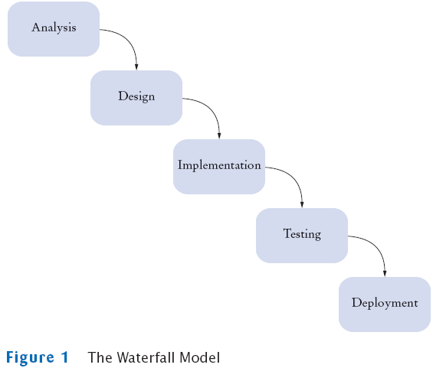

The waterfall is developed with five process and the first comes analysis where the project is analysis and gather the requirements before starting the process of waterfall. Then it comes design where it contributes the UI parts. Then implementation uses the specific programming language then it testing will find those system whether it has fault or not. Then it will deliver to the clients.

### Design pattern

Design pattern can be used a navigation tools or a guideline to work with the system. Design is used to reduce the level to complexity in the system. Where I am using MVC pattern in my website that means Module, View, Controller pattern. Model-View-Controller is an architectural pattern which is used in developing user interface that is divided into three interconnected fragments.

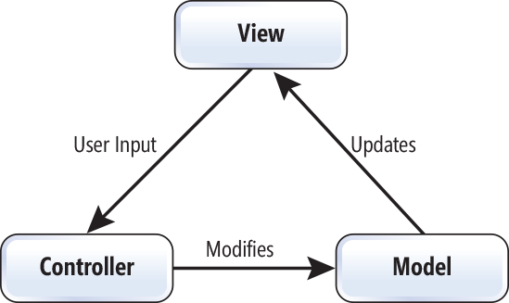

# Chapter 2 Analysis

## Introduction to analysis

I have done analysis to break a whole system into separate components for different examination. Before doing analysis, I have created some steps which can make it easier to use and read. It helps us to do the same task in time which saves our time and efforts.

Here I am creating a dynamic website about the topic “THE GAME INFO” web-based application which it focuses for the new and most trending way to implementing. To develop the website, I have gone through the market to gather data and information about developing and maintaining the website. Analysis is the first process to create a website which contains all the data and information to develop the software package. It helps the world wide to assemble the necessity and wants to develop the software.

### Feasibility Study

Feasibility study tells us whether the project is worth the investment because it regulates the ideas which is to ensure a project that is technical and legal feasible with the economical factor. It is a process to analysis in measuring likelihood and ability to finish a project fully including some related factors. Feasibility is defined as the extent to which a program or a project can work successfully without any errors and bugs. There are 5 types of factors which are tabulated below:

|  |  |
| --- | --- |
| 1 | Economic feasibility |
| 2 | Technical feasibility |
| 3 | Schedule feasibility |
| 4 | Operational feasibility |
| 5 | Legal feasibility |

### Economic feasibility

Economic feasibility is the process of calculating the cost and the logistic outlook for an organisation project or endeavour. Economic feasibility is done with in the four walls of an organisation and sometimes the organisation hires some external company which is specializes in accompanying economic feasibility for the organisation. In this case we have set it to our budget and won’t exceed more than that.

### Technical feasibility

Technical feasibility is the study of the details how the product are severed to the customer.

We have set the transportation system and intend the deliver product and services to our customer. Materials and supply is all set to our business location.

### Schedule feasibility

Schedule feasibility is done to complete a given project within its scheduled time limit, by the planned date. If the project is completed in the given time period those will be appraised as high so we also keep up with the scheduled time period.

## Analysis Methodology

For this assignment to be completed I have chosen (SSM) which stands for Soft System Methodology analysis. It is also called people-focused analysis which focus on people thoughts rather then system. I have done this analysis using different software and methods such as use case diagram and tier architecture. It indicates Pine Tree State to assemble necessities.

### Rich Picture

It is a method of exploring differently in which I have created the diagram by sketching which gives the scenario of expressing the diagram easily to understand. It is just a rough sketch of a real diagram.

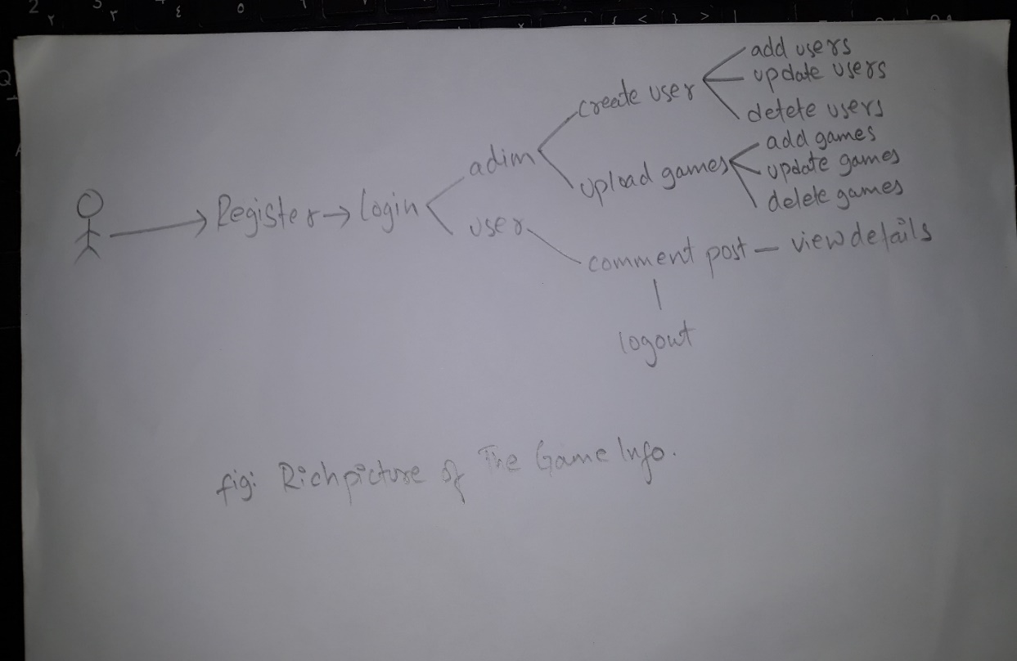

### Root Definition

Root definition means “root” itself refers the top-level directory of the file system. The word is derived from the word tree root, since it is known as the starting point from hierarchical tree structure. The folder inside the tree structure represents branches, while the files are called leaves. Just like the real-life tree, a data tree can be pictured upside down, where the root at top and the subdirectories hanging downwards. Root directory is also called the root node of life system. For example: “C:\ defines the root directory of the drive C that ends with “/users/Fred”.

### Conceptual Model

Conceptual model represents the composition of concepts which are used to help user understand, know and to simulate the model represents. It is also known as a set or group of concepts. Conceptual model is also distinguished as domain model. Conceptual model is a summary-level data model which is mainly used in strategic data assignment. There are 3 ways of representing the conceptual model that is triple E which are as follows:

* Efficacy:

This system is mainly used in small structure and scale organisation which helps in exporting and importing the items and goods in exact time.

* Efficiency:

As this is a web-based application where it needs internet access to run. It is simple software where it only uses small amount of resource to run.

* Effectiveness:

This is a framework holding its maximum data and information which can be used it further coming years and it holds as long as the administrator of that current framework needs. They ca use it for the long period of time and yet I suggest to keep the framework renovating time for the better result and execution.

### Software requirement Specification

Software requires where the webpage can handle HTML 5 player, CSS 3 and above, flash player, java script. The software requirement specification is created based on the interaction between prescribed worker and client. To accomplish the website to run we need to have positive correspondence with the client to gather all the requirements and necessities.

### Hardware requirements Specification

Processor: intel core processer or higher

RAM: 1GB or higher

Operating System: Window XP or higher

Screen resolution: 1024 x 768 and above resolution for better performance

## Functional Requirements

Function requirement is the source capacity of framework and its sectors. It is used to identify the equipment, information control, programming, computation and handling the characterize of framework should accomplish.

The function requirements which is my assignment is mentioned below such are as:

ID: FUN1

Title: User Registration

Description: User can register with their valid data and information

Rational: It helps the user to get current account in the website and can log in.

Dependencies: N/A

ID: FUN2

Title: User Login

Description: User can login with their valid username and password which they have used to create the account

Rational: it gives the permission to access the system or website.

Dependencies: N/A

ID: FUN3

Title: Create Post

Description: User create new post and games in the website.

Rational: It helps user to create new post and upload new games when games come in the market.

Dependencies: FUN1

ID: FUN4

Title: Add function

Description: User can use the ADD function.

Rational: It helps them to add new function in the website

Dependencies: FUN1

ID: FUN5

Title: Delete function

Description: User can use the Delete function.

Rational: It helps them to delete post and comments in the website

Dependencies: FUN1

ID: FUN6

Title: Read function

Description: User can read and view the website.

Rational: It helps them to view and read the website.

Dependencies: FUN1

ID: FUN7

Title: Update function

Description: User can use the update function to edit or update posts and comments in their posts.

Rational: It helps them to update or modify the posts.

Dependencies: FUN1

ID: FUN8

Title: View answer

Description: User can view their answers where they asked admin about the question.

Rational: It helps the user to keep up with the all the answer asked to admin.

Dependencies: FUN1

ID: FUN9

Title: Logout

Description: User can logout from the website.

Rational: It helps to logout once the process is done by the user in the website.

Dependencies: FUN1

ID: FUN10

Title: Categories

Description: User can use the categories option for the posts and games they are looking for

Rational: it can help to quickly search for the game’s user are looking for.

Dependencies: FUN1

ID: FUN11

Title: Ask Admin

Description: User can ask admin for more further question.

Rational: it can help user to get information which they are struct and report bugs in the website to improve the website.

Dependencies: FUN1

ID: FUN12

Title: Blogs

Description: User can access quickly about the new and recent posts and games in the website.

Rational: it can help to quickly access about the new games.

Dependencies: FUN1

## Non-Functional Requirements

Non-Functional requirements are those function which cannot be changed in the website or the system. They are useful to the system but are as well important to the software or system.

ID: NFUN1

Title: Performance

Description: The system should work smoothly and without any lag.

Rational: Productivity maintained

Dependencies: N/A

ID: NFUN2

Title: Usability

Description: It should be user friendly and easy to understand.

Rational: User will not find it difficult to use the system.

Dependencies: N/A

ID: NFUN3

Title: Response time

Description: It should be quick to response to user.

Rational: rapid responding.

Dependencies: N/A

ID: NFUN4

Title: Security

Description: User with correct username and password can access the data and information

Rational; Data confidentiality

Dependencies: N/A

ID: NFUN5

Title: Reliability

Description: The system should be reliable and accurate.

Rational: Maintenance of reliability.

Dependencies: N/A

ID: NFUN6

Title: Availability

Description: software should run with user.

Rational: upholding the availability

Dependencies: N/A

ID: NFUN7

Title: Maintainability

Description: The software can be in maintenance in future.

Rational: Upgrading the system can improve better experience

Dependencies: N/A

ID: NFUN8

Title: Recoverability

Description: there should be backup storage if when the system falls.

Rational: Data availability

Dependencies: N/A

Prioritization

Functional Requirement

|  |  |  |
| --- | --- | --- |
| ID | Functional Requirement | MoSCoW |
| FUN1 | User Registration | Must Have |
| FUN2 | User Login | Must Have |
| FUN3 | Create Post | Should Have |
| FUN4 | Add Post | Must Have |
| FUN5 | Delete Post | Must Have |
| FUN6 | Read Post | Must Have |
| FUN7 | Update Post | Must Have |
| FUN8 | View Answer | Could Have |
| FUN9 | Log Out | Must Have |
| FUN10 | Categories | Should Have |
| FUN11 | Ask Admin | Could Have |
| FUN12 | Blogs | Must Have |

Non-Functional Requirements

|  |  |  |
| --- | --- | --- |
| ID | Non-Functional requirements | MoSCoW |
| NFUN1 | Performance | Could Have |
| NFUN2 | Usability | Could Have |
| NFUN3 | Response Time | Could Have |
| NFUN4 | Security | Should have |
| NFUN5 | Reliability | Should have |
| NFUN6 | Availability | Could have |
| NFUN7 | Maintainability | Could have |
| NFUN8 | Recoverability | Could Have |

# Architecture

Software Architecture means to maintain the structure of client, application and client tier of architecture. It refers to the fundamental structures of the system and the behavior of creating those software or system. In simple words, it means software architecture is the process of converting reusability, scalability, flexibility and feasibility into technical and organization expectation.

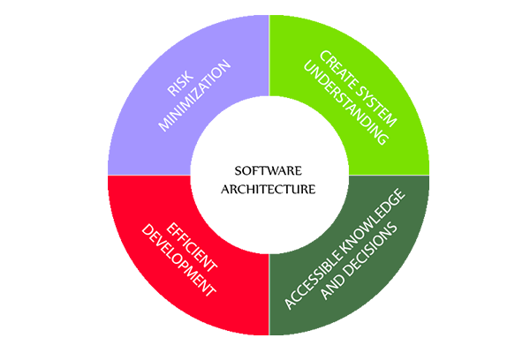

The life cycle of software architecture represents four ways and they are as follows:

* Risk Minimization
* Create System Understanding
* Accessible Knowledge and Decisions
* Efficient Development

Software Architecture is known as the blue print for system and the project developing it, which the work is assigned should be carried out by implementation and design teams. The Architecture is the main source of carrier of qualities in system such as security, modifiability, performance.

## NLA

Selecting all the nouns and verbs:

|  |  |
| --- | --- |
| Nouns | Verbs |
| Time, people, modern, days, person, world, technology, posts, categories, book, user, book, electronic, read, games, application, software, admin. | User added, user deleted, user update, games added, games removed, font adjustment, personal details, view comments, view answer. |

Identifying candidate class from the game info

|  |  |
| --- | --- |
| SN | Candidate class |
| 1. | User |
| 2. | games |
| 3. | admin |

Identifying verbs from the game info

|  |  |
| --- | --- |
| SN | Verbs |
| 1 | Add user |
| 2. | Remove user |
| 3. | Update user |
| 4. | Add games |
| 5. | Remove games |
| 6. | Font adjustment |
| 7. | Personal details |
| 8. | View comments |
| 9. | View answers |

## Initial class diagram of the game info

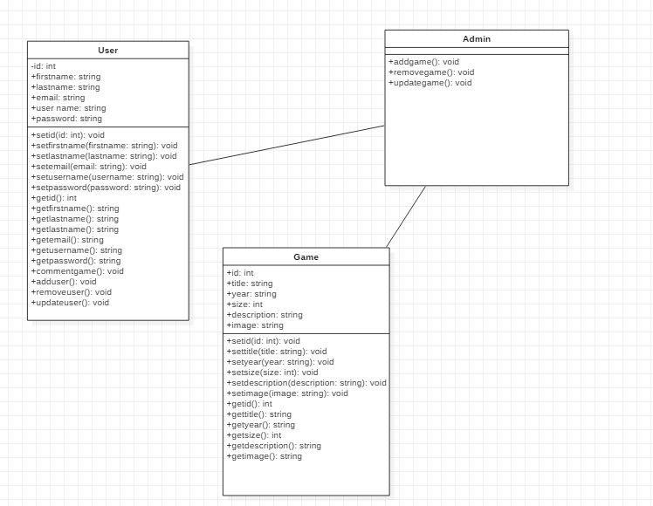

## Use Case Diagram

Use case diagram is the simplest way to show the interaction of users with the system that representation the relationship between user and admin towards the system. The diagram can identity where the user and admin are interacts with system. It is drawn to capture the functional requirements of the system. It is a list of events or action steps that defines the u=interaction between a system and a role to achieve goal.

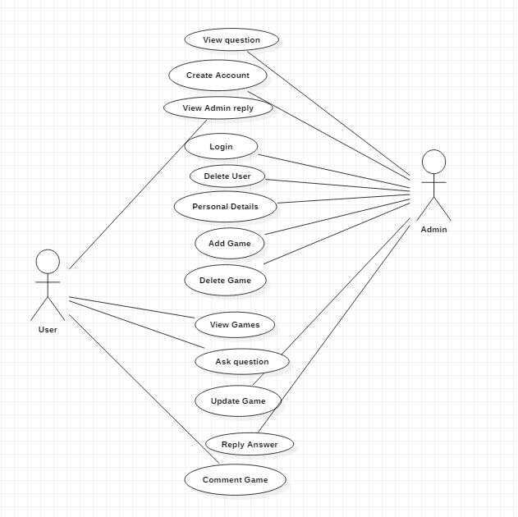

Figure 1:use case Diagram

# Chapter 3: DESIGN

# Justification

Design is the process to solve the possible problem. This technique is helpful for overcoming those problems which may arise in future while working In small and core level project. I will use some software to create the design and prototype This process is done after analysis phase which is much composite than analysis. Here we gather user requirement and after analyzing user requirement we perform best possible design that can be made.

There are mainly two types of design which we described below:

1. Conceptual design: Here conceptual denotes customer.
2. Technical design: Here technical denotes system builders.

## Structural design

Here structural design focus on structural modelling of system which capture static feature. This contain following:

1. Class diagram
2. Object diagram
3. Data flow diagram

Structural design is the process where we can find safe and serviceable specification of materials and member type, size and configuration to carry loads and it supports each other in sharing the loads.

1. Class diagram

Class diagram represents a set of objectives which has similar relationships, operation and behavior. Class diagram describes the object and classes inside the system and the relationship between them. It is also a classifier that describe the set of objects. Class diagram is mainly used in structural diagram. In UML class diagram is essential elements which has some

* Attributes
* Class
* Relationship
* Operation
* Constraint rules and notes

Relationships is class diagram are:

* Association: Association is also a structural relationship, which specific the object of the first class are connected to object of another class. i.e. an employee is working for a particular company.



* Generalization: It specifies the object of the sub class of one identical for object of the general class. It is a relation.

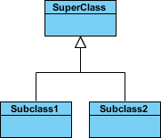

* Dependency: The whole part is dependent to life time.



* Realization: An interface can be grasped by many of the classes.





Figure 2: Final class diagram

Firstly, the user can have id, first name, last name, email, username, password. User can login in the website using id and password which was register in the game details. User can comment in the post and games. It can add user and remove user and update user.

## Architectural design

Architectural design are basically a data structure that represent the build of a computer based system. It’s the logical and conceptual structure organization of a computer based system. An idea which then takes part in forming a structure turns into a whole or computer system. Architectural design has context in the system

* External entites of a context diagram model in which the system interacts.
* System engineer must context in the model.

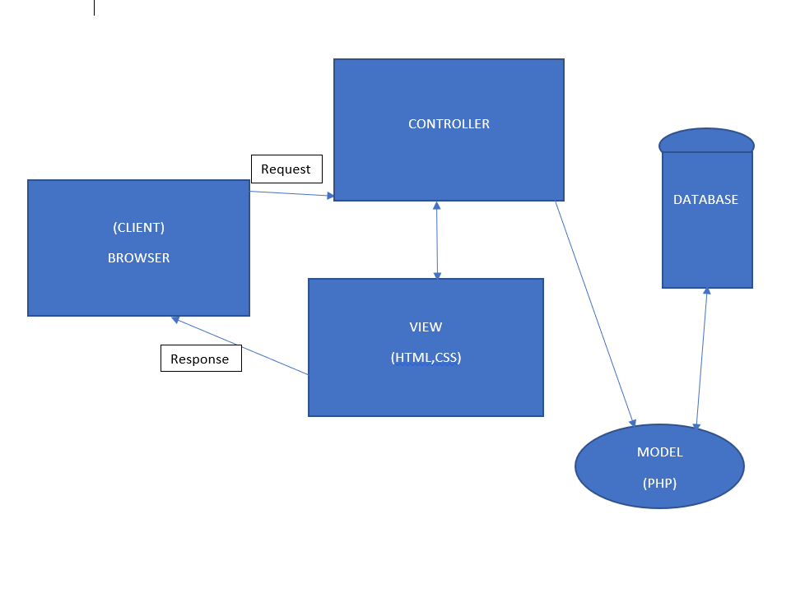

## Dataflow diagram

* The dataflow diagram is a hierarchical graphical model of a system which process the activities and function made by the system performs where the data is interchange with the following function.
* Symbols that are used in dataflow diagram are as follows:

1. External entity: It is the source of information which flows throughout the system and where information leaves the system.
2. Process: This are the activities that are carried out by the system which is use to use and transform data and information.
3. Dataflow: Those dataflows happening in the system are noted by a named arrow.
4. Datastore: It is the storage of all the information within the system.

* Dataflow model graphically represents the transformation of the data input through a hierarchy levels to the final data.

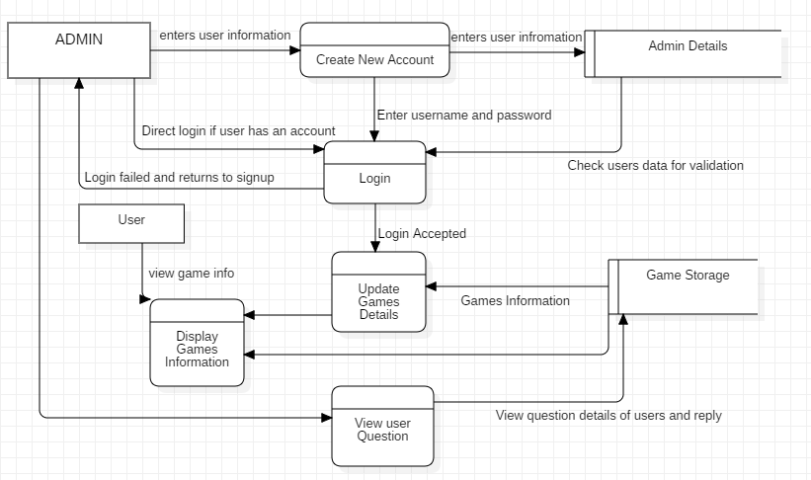

Figure 3: DFD diagram

## Behavioral diagram

Behavioral diagram consists of both activity diagram and sequence diagram.

1. Activity

* It is a special kind of diagram that shows the flow of activity diagram to activity.
* Activity diagram states the dynamic view of the system and its interface.
* They are mainly used in modeling the function within the system and the control flow among the objects.

|  |  |
| --- | --- |
| **Symbol** | **Name** |
|  | Start Symbol |
|  | Activity symbol |
|  | Action flow symbol |
|  | Decision symbol |
|  | Fork symbol |
|  | Joint symbol |
|  | End symbol |
|  | Note symbol |

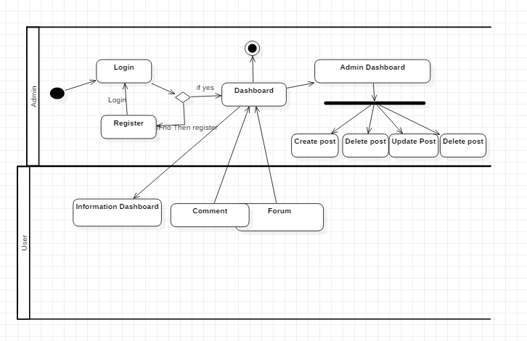

Figure 4:Activity diagram

## Database modelling

There are two kind approaches of database design that are

* Bottom up
* Top down

Bottom up is used for collecting information and data for example: in game info we collect all the data of post and comments and the entities and which shows the relationship where as top down means to break large entities into small entities.

### Data dictionary

* It is a storage where data and information contains of data flow process and data storage.
* It is a repository of data of data.
* It is a set of all data and information of flow diagram elements.

The data dictionary contains following item and are as follows:

* Data structure: It is a set of element handled with in a unit.
* Data element: Smallest unit of data doesn’t not contains further decompostion.
* Data flow and data stores: Data flow are motion and data stores means where data structure are stored.

|  |  |
| --- | --- |
| Symbol | Name |
|  | Entity symbol |
|  | Attribute symbol |
|  | Zero to many relation |
|  | One or many relation |
|  | Zero to one realtion |
|  | One to one |

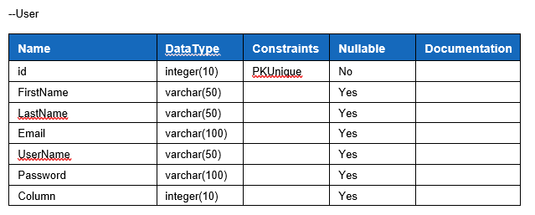

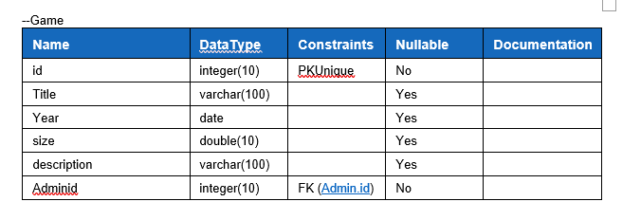

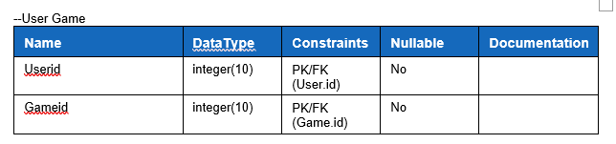

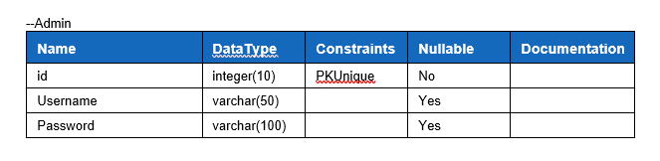

### ERD

Entity realtionship modeling:

* Entity realtionship is a systematic way to describing business process.
* Diagram which is created by relationship, entities and attribuites graphically are known as entity realationship diagram.
* Various properties attributes of entities can characterize them.

The main components in database design are mentioned below:

* Relationship: It represents the relationship entites.
* Entity: Entity can be place, person, thing or an event.
* Attributes: Attributes are the process of describing entity.

ER diagram are categorised in four types of relationship which are as follow:

* One to one realtionship
* One to many relationship
* Many to many relationship
* Many to one relationship

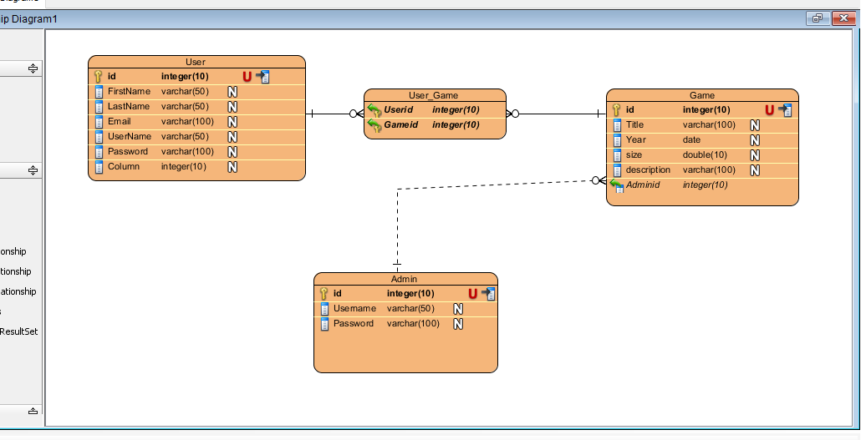

## UI Design

User Interface is short (UI) design is the process and maintaining iterface wit in the computerized device or system with a special focuse design, style and looks.User Interface is an iterative process where is it often talked about the user experience which includes the interface and appearance of the device or system.

1. User interface is a front end application view where the user interacts with the system to use it.
2. User interface manipulate and control hardware and software of the user.
3. For example: If my game info is complicat to use by gamers and users for that the user interface should be user friendly and easy to use.
4. Users becomes familiar to the certain way to use the layout and interface. Doing so will get easy with task completion, satifaction and to be consistent.

There are some user interface design fundamentals which leps in improving such as:

* Know your User
* Stay consistent
* Pay attention to design, layout and patterns
* Use visual hierarchy
* Feedback is necessary
* Be forgiving
* Empower the user
* Speaking with the current language
* Keep it simple as possible
* Keep moving straight and forward

### Digital Prototype

Digital prototype is a conceputal design for all the fields and in desiging website where it provides a virtual explore expericence of a complete product before its build. Digital prototype gives a wider range of testing opportunities unlike paper prototype. Where in my website I have used a software called (BALSAMIQ) for the run test. It is a software to create a didgital prototype wit al the features before taking it into action and made in reality.

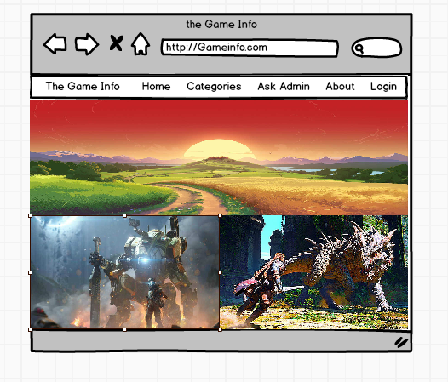

Figure 5: HOME

Home is where user is shown an d taken first in the webpage is HOME. They are explore about the webpage and see what they are looking for. It has all the information needed to view the webpage.

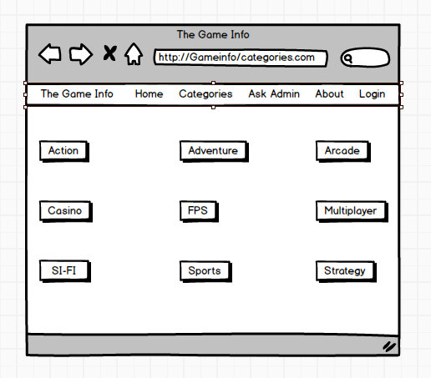

Figure 6:CATEGORIES

Then in the categories area they can search for the games they are looking for the games and new games and can access to all the game details. There are total of 9 option in categories sector.

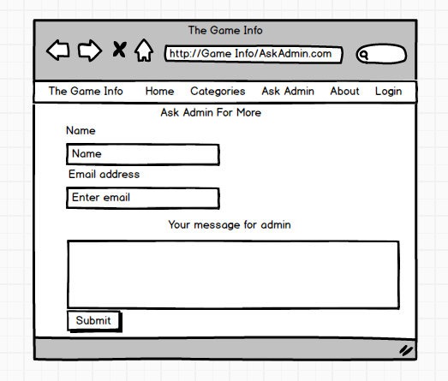

Figure 7:ASK ADMIN

It is for those users who wants to create a post or to upload of their games in the following website and for asking more question and the admin will try to give reply of those question with in a day or more. They can even contact admin for further details and information with is not in the website.

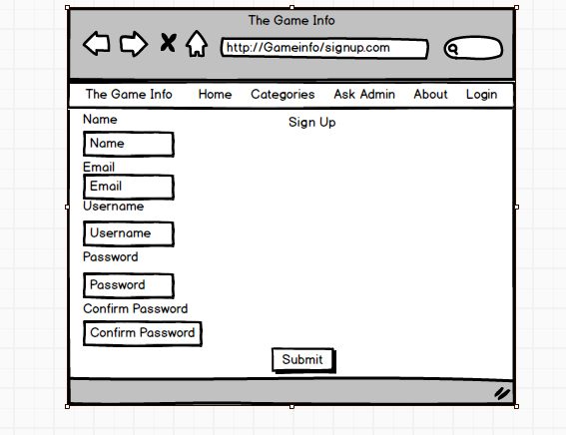

Figure 8: SIGN UP

It is the page to create new user and it has only access with the admin for which the user has to contact the admin in the “ASK ADMIN ” sector. User has to give some details to create their own account in the website.

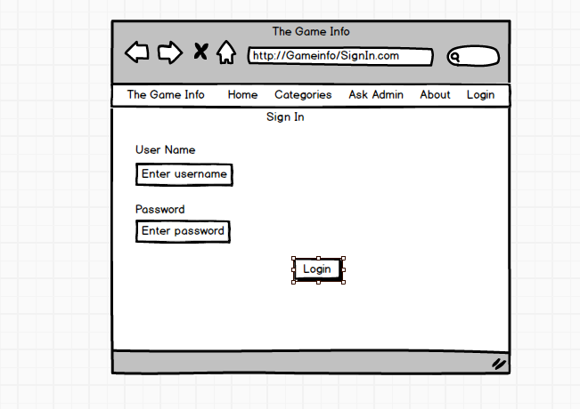

Figure 9:SIGN IN

It is where the user has to give their username and password which the user can create their account in the “Sign UP” sector. With that all they can access to create a post, delete their post which they can’t delete or edit others user post and games.

# Chapter 4 Implementation

## Introduction

It is the fun part of every developer and user because it where all the coding and commands are written in software to create a website or application. Coding is the process to communicate with the system.

## Programming language

There are different kinds of programming language to create a website like Lara bell, php, JAVA, python etc. and I have selected PHP because it the most used programming language to create a web-based application software cause of:

1. Security
2. It is easy to use and to interact with the system.
3. Pages and model can be easily be readable.

For the software to work I have selected XAMPP control panel where I can access my PHP code and deliver in webpage without it I couldn’t have completed my project. The reason I have chosen this software:

* It is a very popular use control panel.
* It is stable with new projects and easy to use.
* The user interaction is smooth.

## Coding and user Interface

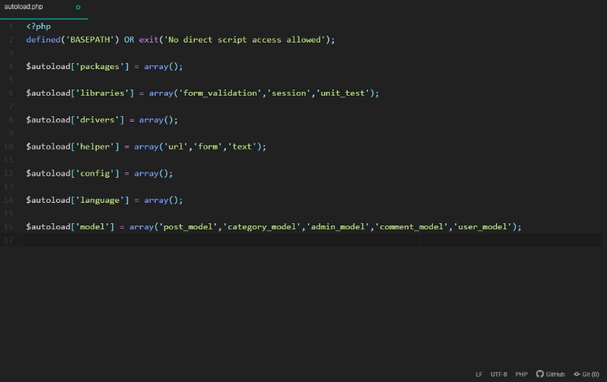

Figure 10:autoload.php

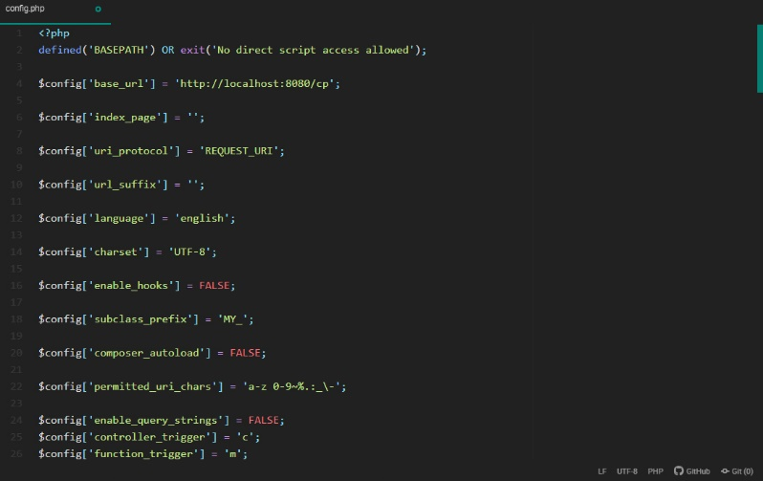

Figure 11:config.php

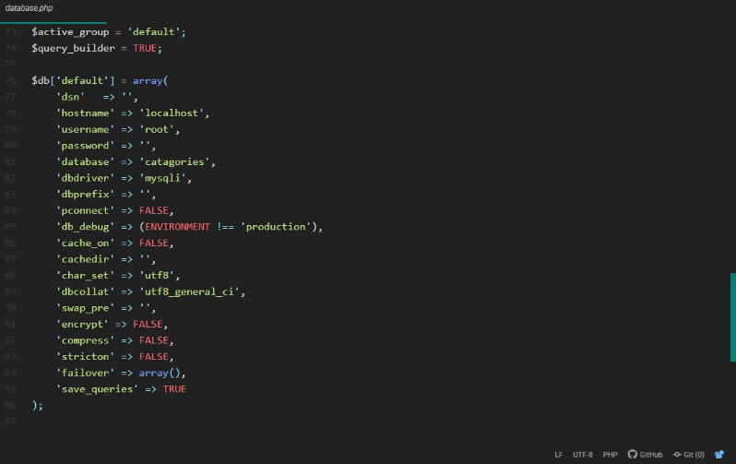

Figure 12:database.php

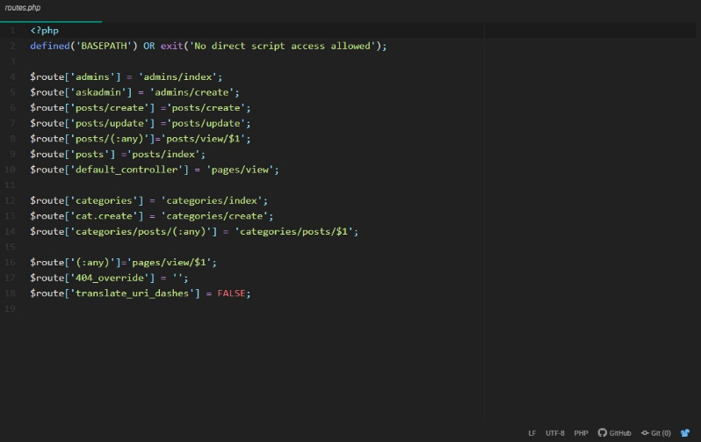

Figure 13:routes.php

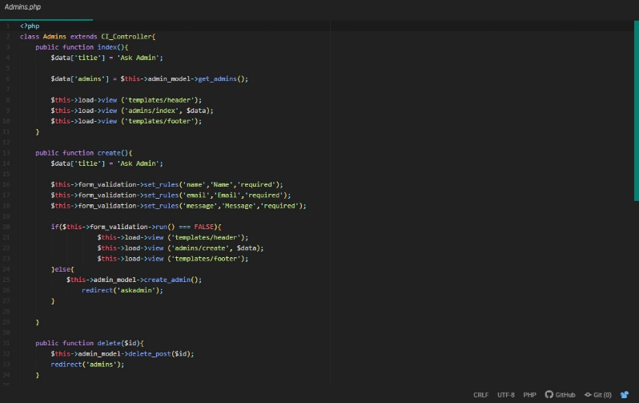

Figure 14:admins.php

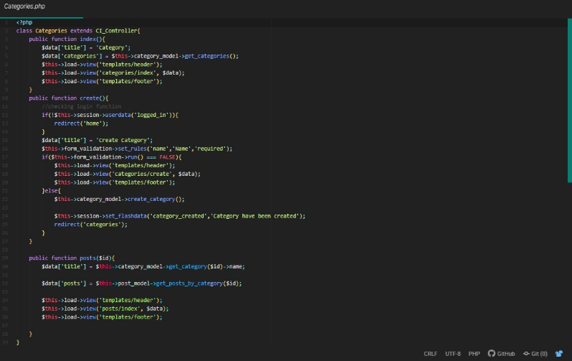

Figure 15:categories.php

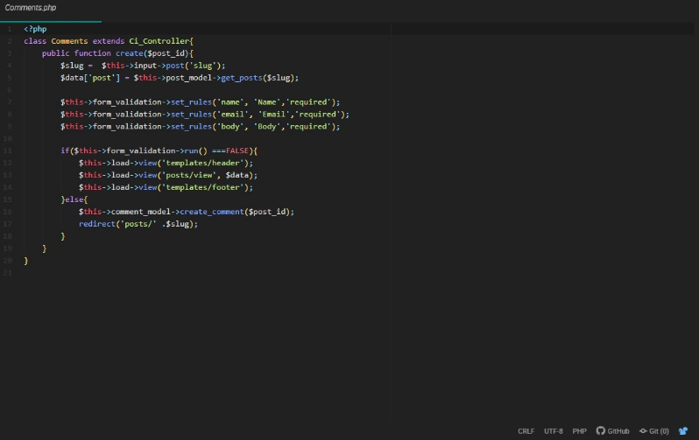

Figure 16:comments.php

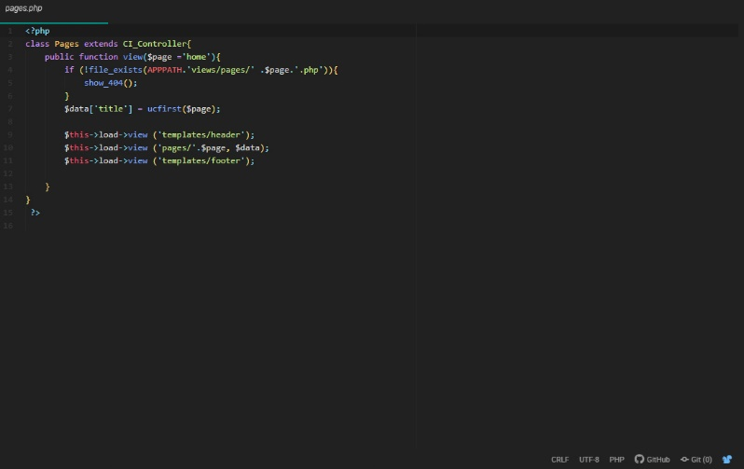

Figure 17:pages.php

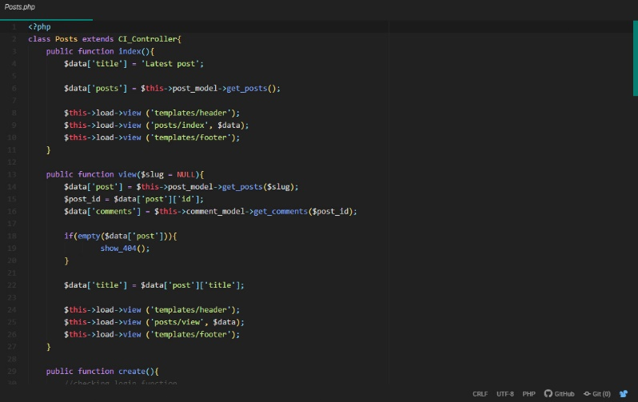

Figure 18:posts.php

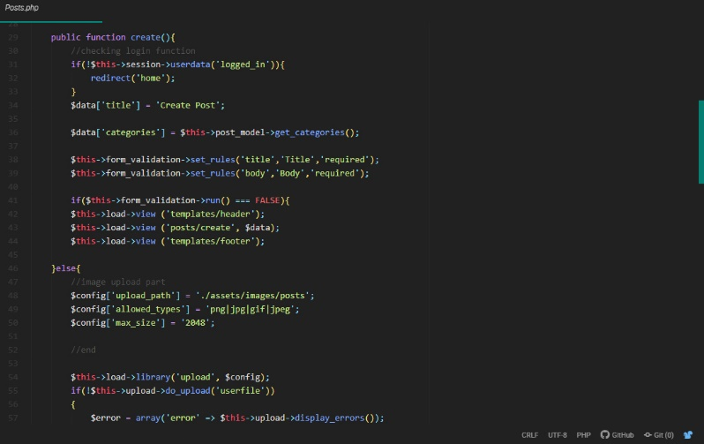

Figure 19:posts.php

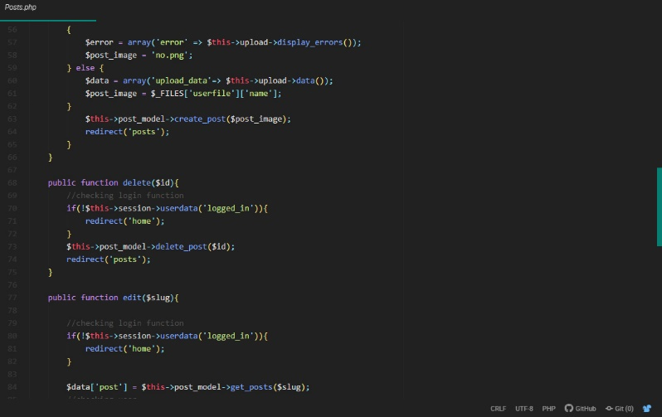

Figure 20:posts.php

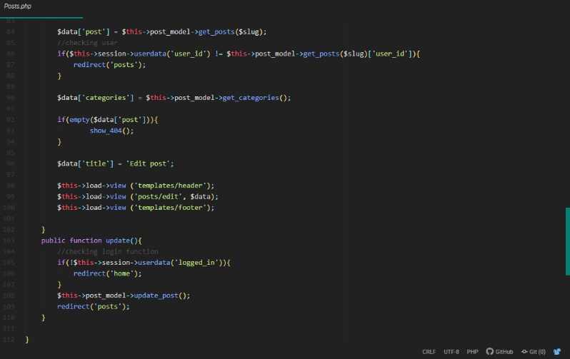

Figure 21:posts.php

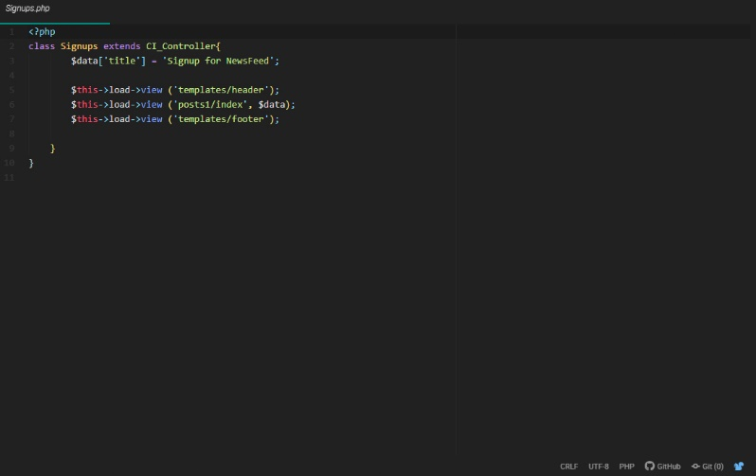

Figure 22:signups.php

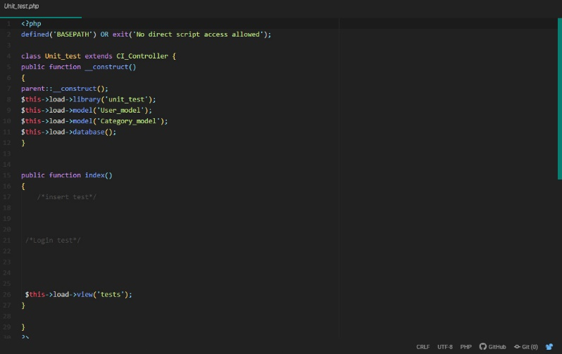

Figure 23:unittest.php

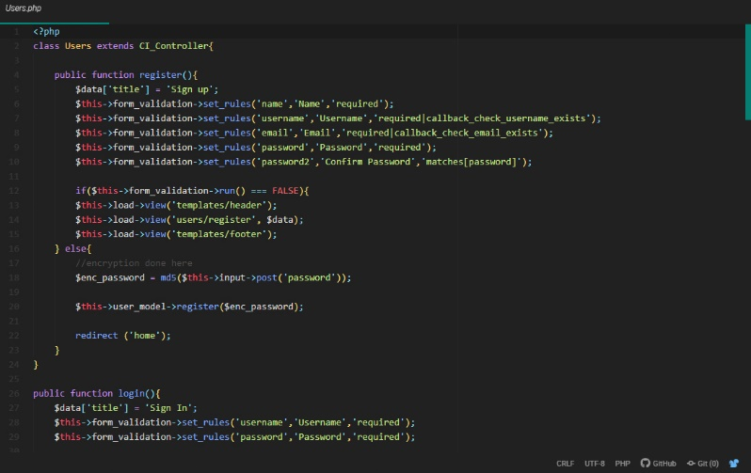

Figure 24:users.php

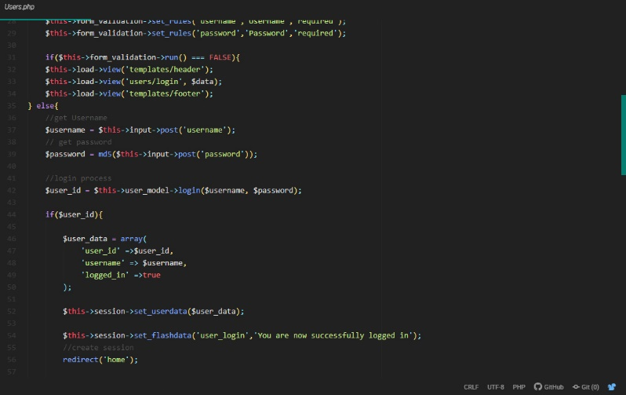

Figure 25:users.php

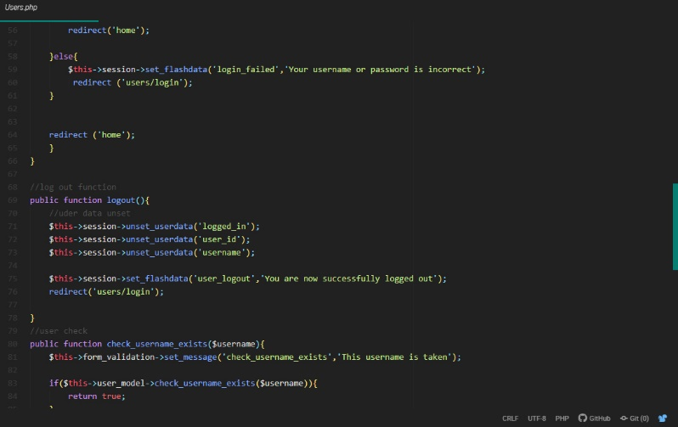

Figure 26:users.php

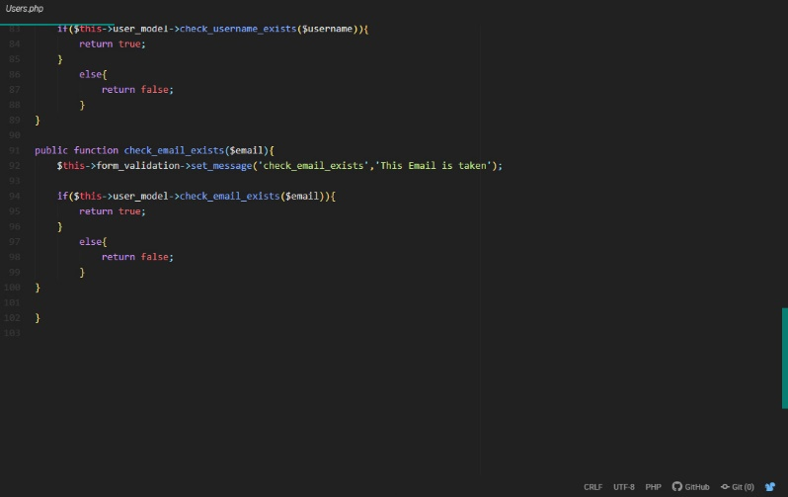

Figure 27:users.php

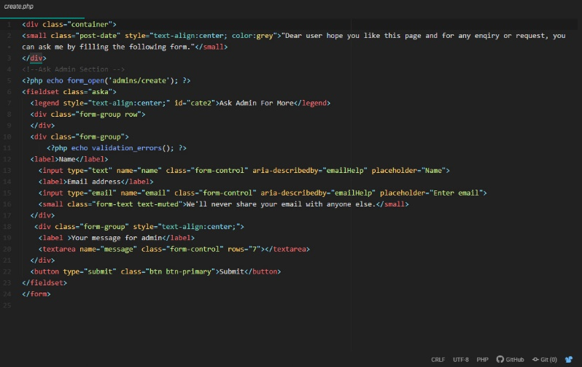

Figure 28:create.php

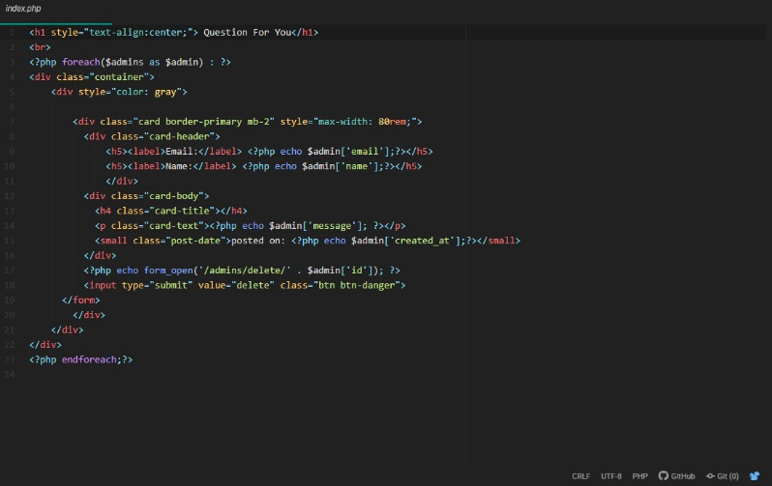

Figure 29:index.php

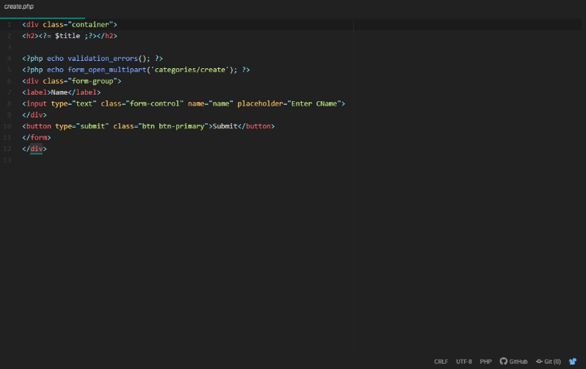

Figure 30:create.php

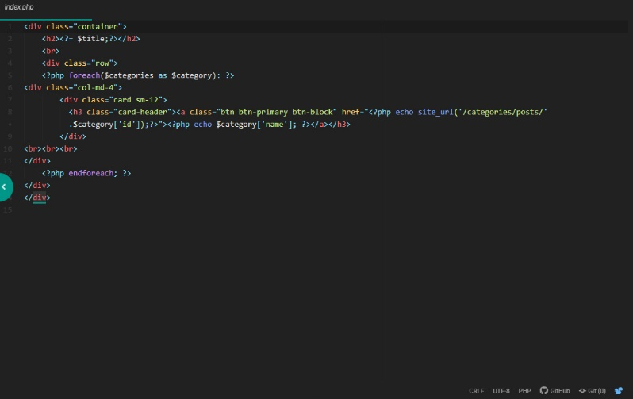

Figure 31:index.php

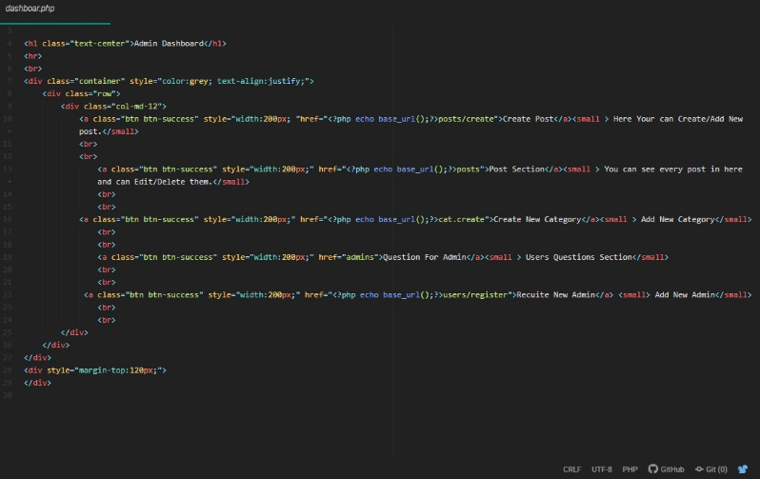

Figure 32:dashboard.php

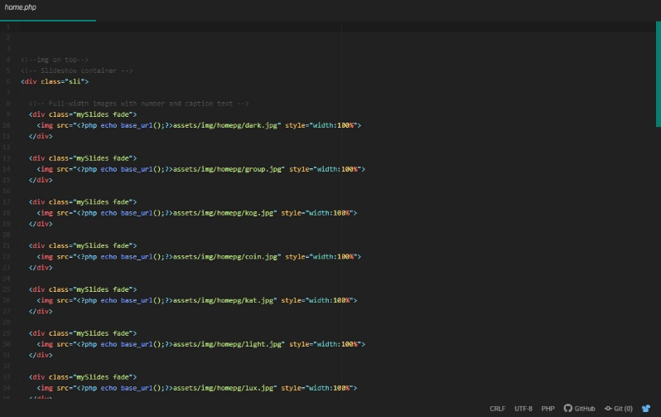

Figure 33:home.php

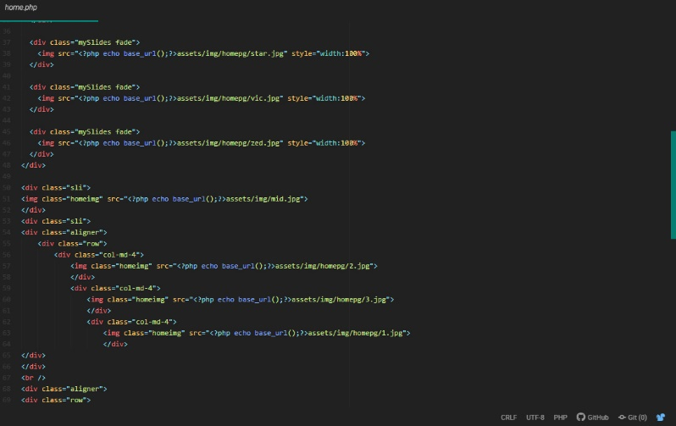

Figure 34:home.php

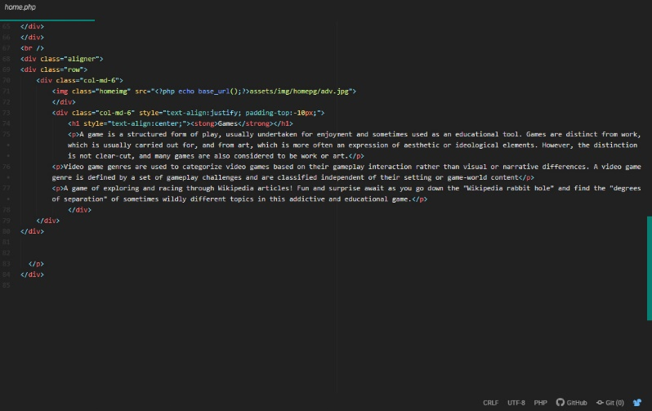

Figure 35:home.php

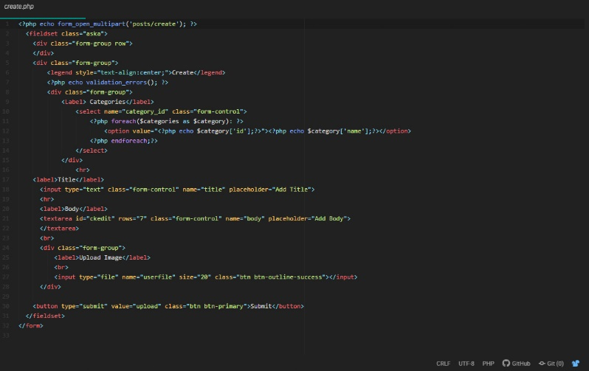

Figure 36:create.php

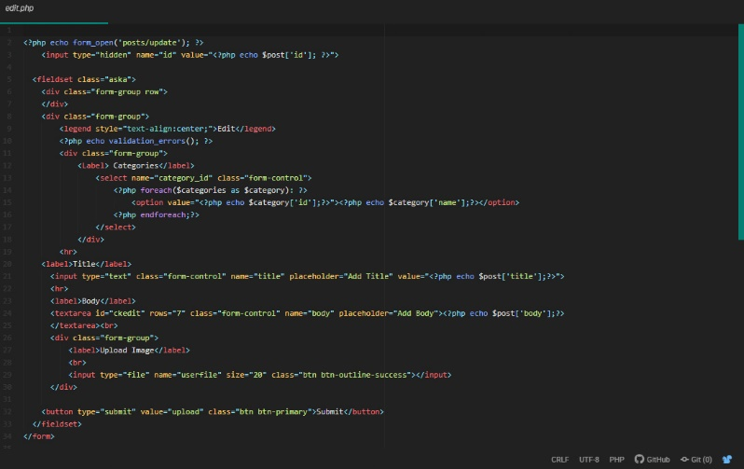

Figure 37:edit.php

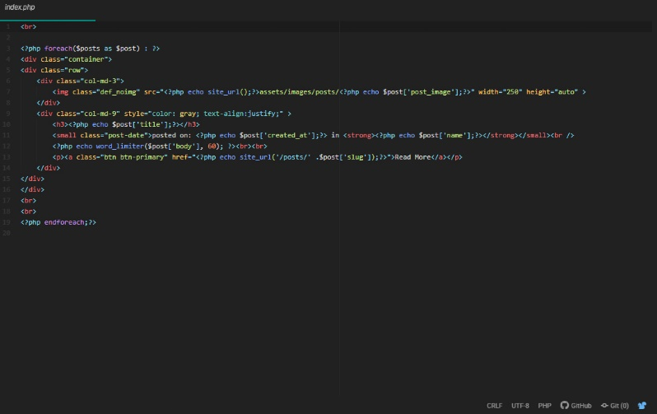

Figure 38:index.php

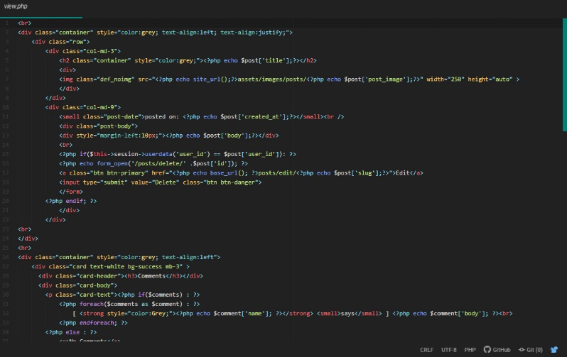

Figure 39:view.php

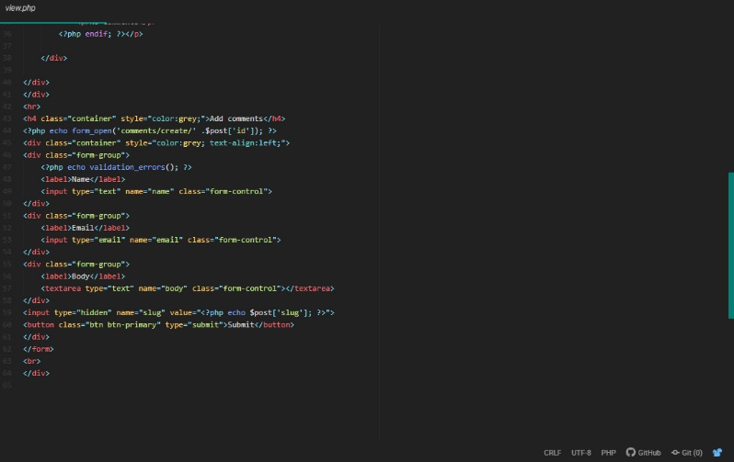

Figure 40:view.php

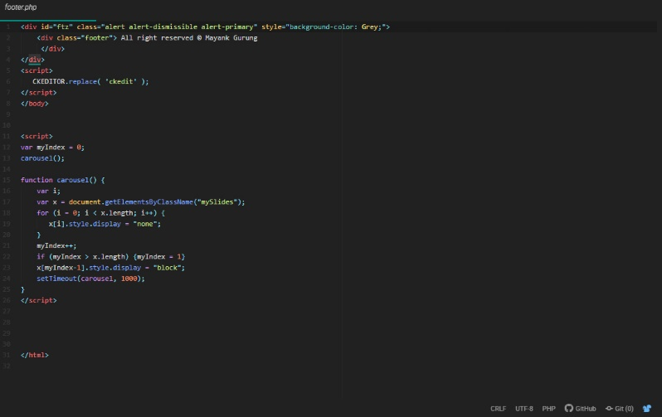

Figure 41:footer.php

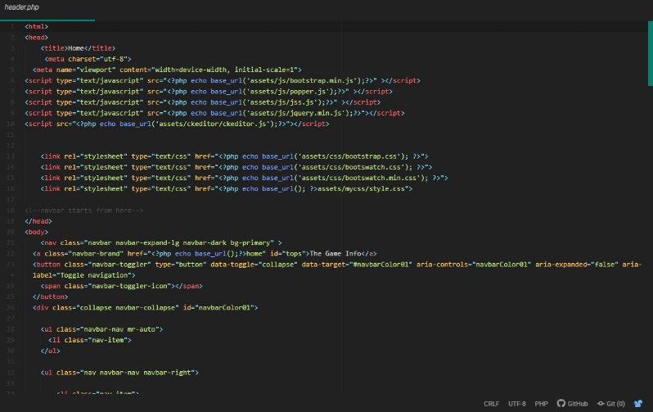

Figure 42:header.php

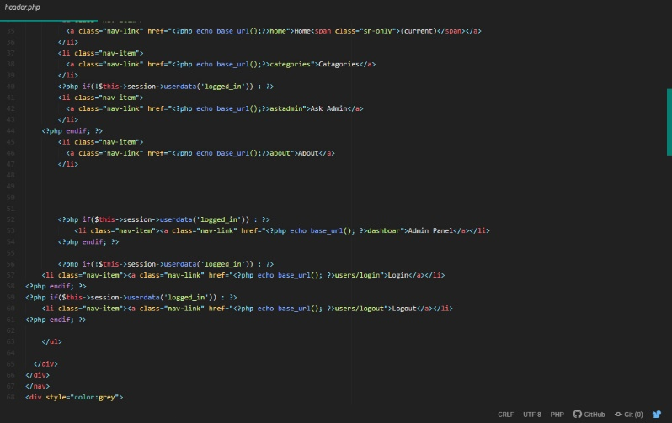

Figure 43:header.php

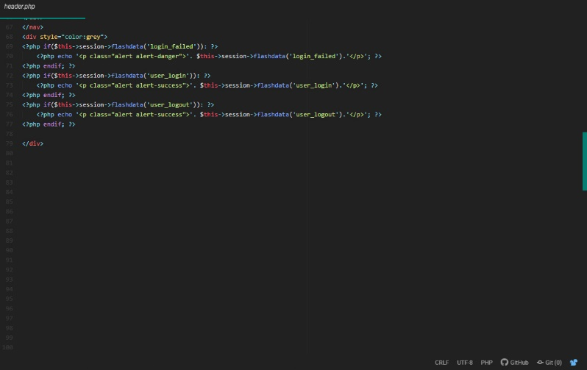

Figure 44:header.php

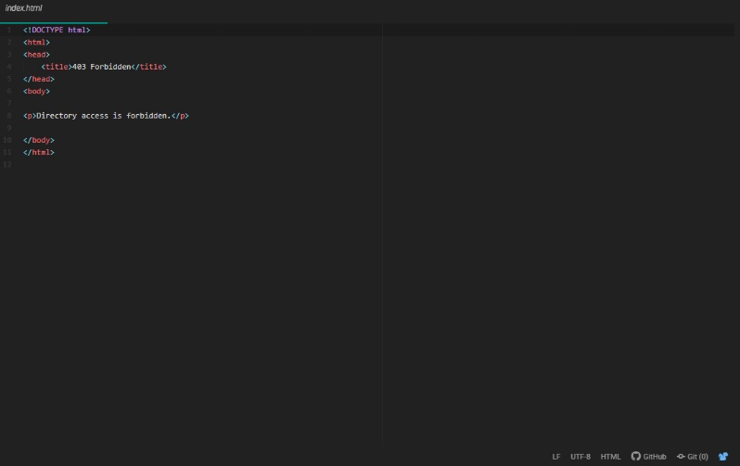

Figure 45:index.html

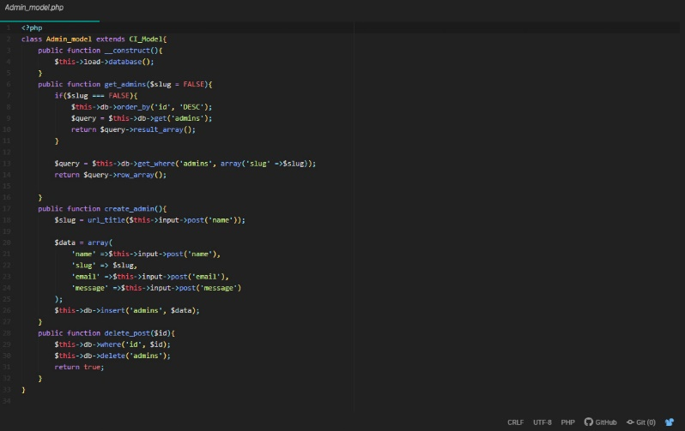

Figure 46:admin_model.php

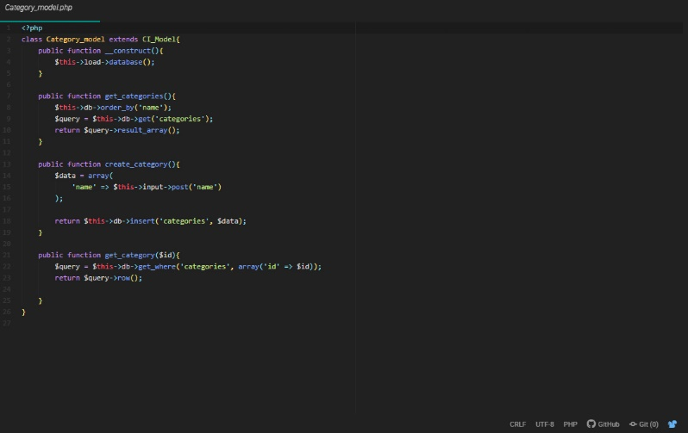

Figure 47:category_model.php

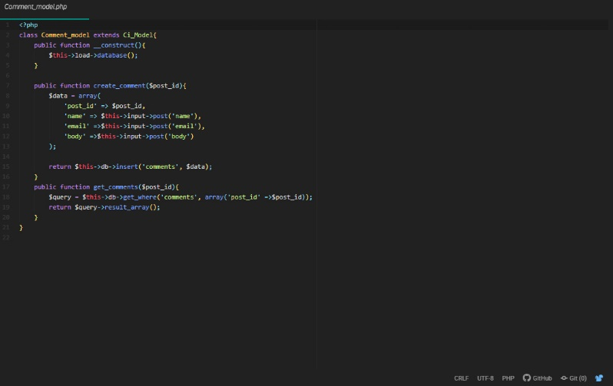

Figure 48:comment_model.php

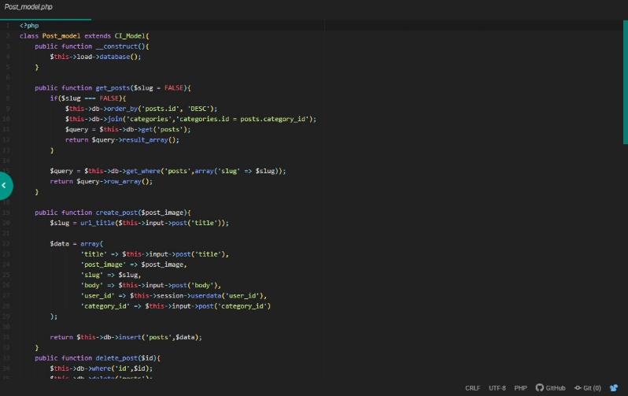

Figure 49:post_model.php

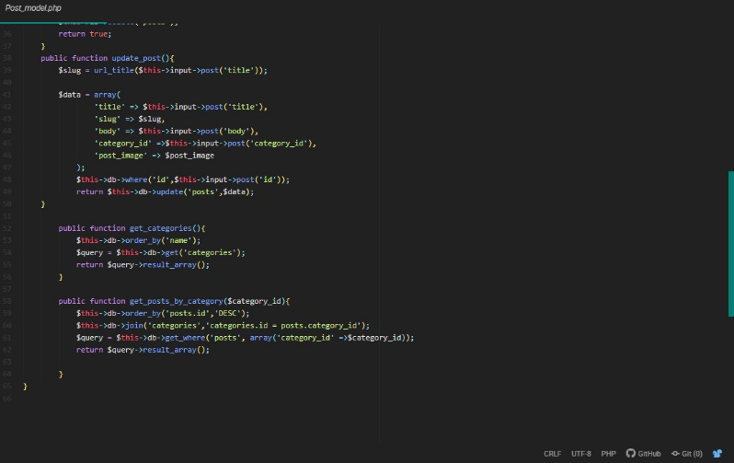

Figure 50:post_model.php

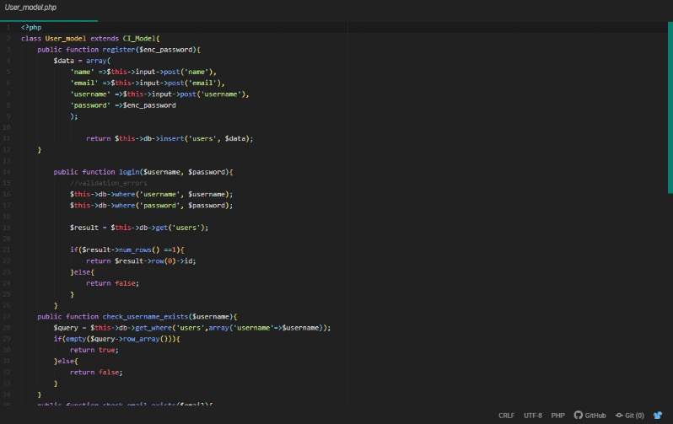

Figure 51:user_model.php

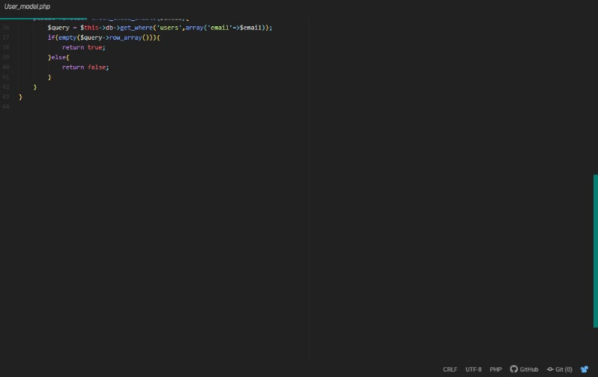

Figure 52:user_model.php

# Chapter 6 Other project issues

## Risk management

Risk management is the process to recognize the risk and consequence and analysis them and take action and precaution on the happening risk. To reduce risk and avoid all the other risk. It helps to keep the assignment free of risk and meet the goals. Risk management is calculate using livelihood, consequence, impact.

The formulae to identify the risk is by

Impact = Livelihood x Consequences

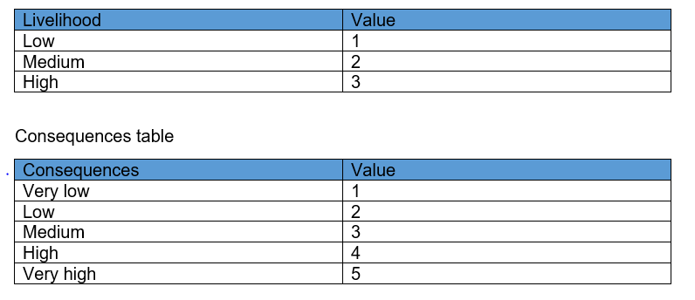

|  |  |  |  |  |
| --- | --- | --- | --- | --- |
| Risk | Livelihood | Consequences | Impact | Action |
| Unwanted Errors | 2 | 4 | 8 | Due to wrong code or message printed or labeled in the development process |
| Time consumption | 2 | 3 | 6 | Due to loss of time in Php and coding sector, I couldn’t manage all the features in time but I have done in MoSCoW prioritization. |
| Operating system may not work properly | 3 | 3 | 9 | Since I had window vista which did not support my operating system and I had to update into window 8 and higher. |
| XAMPP Failure | 1 | 2 | 2 | Due to load in system sometimes Xampp does not work properly. For that I had to restart the system and restart the client. |

## Configuration Management

Software Configuration management means to manage the files and folder of a development project where it is used by software engineers used in standard way so that organization can make changes with the current situation. It helps in the controlling of version, track changes and to distinguish individual elements. There are many ways to manage configuration management where I have selected by running Command prompt function and the configuration of “The Game Info” is shown in the following figure using Command prompt function.

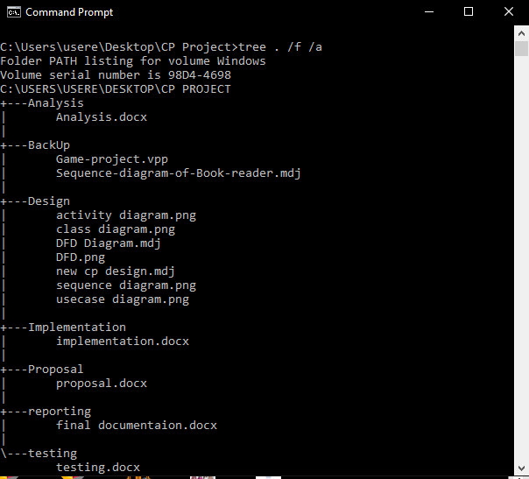

## Project issues

So, as I started developing the web-based application I faced with many issues during the development where my coding didn’t even run for the first couple of days. Then I realized that I was implementing those code in Notepad++ and I found out that it doesn’t support Model-View-Controller pattern (MVC)pattern so had to change the whole system to Sub-lime Text 3 so that MVC pattern as support. Some issues were those where my database didn’t even respond to my code that was in phpmyadmin which is a database so had to change my database name to restart doing the database. Lastly, I ran down with a problem in my CSS which didn’t accessed to my file format for that I had to use some tutorial videos from YouTube. Due to this lack of time management I couldn’t complete some feature which I wanted to add in my website where I have explained the my errors above in the project.

## Limitation

The term limitation means that to have a limit source and resource in everything which is also implement to my website. The Game Info where I have some few limitations of the website and they are:

* It doesn’t show animated trailer for those games.
* It doesn’t show the size of that game.
* It doesn’t give the user permission to edit, delete until logging in.
* Downloading games is not available.

## Future work:

I have successfully completed the development of the Game info website. It was fun developing a website using HTML.CSS. JavaScript and php but due to short period of time I could not give my 100% in the project. So, for the additional or the future work the following are in my list to make the website into the next level:

1. To add an online database server where user can download the game and play. Like Steam.
2. Add online payment system to buy paid games.
3. Pop-Up Notification system when user subscribe the website.
4. To show reviews rate and feedback about the games.

# Chapter 7: Conclusion

Since I am at the end of my project where I came up through a lot of problems and errors which I couldn’t solve those in time but I managed to solve those all in one place. Now the user or gamers don’t need to go through every website and links just to search for a single game and it consumes a lot of time. So, I thought that I could make a website for all the users and gamers which will help them to search all the games under one roof and it could also save a lot of time rather then going to every links and website that some doesn’t even contain the right information they are looking for.

So, I created a website that can easily viewed by all the users and gamers for the games they are looking for. So, likely the past few years people go to market to buy CDs for games they want to play since those aren’t the same time period where everything is online and with a help of internet everything can be done with in a fraction of time. It doesn’t matter whether you are living you can access through all around the world. In order to use more feature like creating your own games and uploading the users or gamers can simply login to the website to use it where they can delete their own post. No other can delete your post expect you. Users can comment in the post they like. Users can ask admin the problems they are facing and needs to be replaced. So with this experience I have learned to consume time and to utilize time where ever necessary and make the website more user friendly and interactive with the user wants.